**DAILY ONLINE ACTIVITIES SUMMARY**

|  |  |  |  |  |  |  |  |  |
| --- | --- | --- | --- | --- | --- | --- | --- | --- |
| **Date:** | **13-06-2020** | | | | | **Name:** | **Javahar S Goutham** | |
| **Sem & Sec** | **7th B sec** | | | | | **USN:** | **4AL16CS132** | |
| **Online Test Summary** | | | | | | | | |
| **Subject** | | **IOT** | | | | | | |
| **Max. Marks** | | **30** | | **Score** | | | **29** | |
| **Certification Course Summary** | | | | | | | | |
| **Course** | **Introduction to ethical hacking(completed)**  **RPA** | | | | | | | |
| **Certificate Provider** | | | **GreatLearning**  **Guvi** | | **Duration** | | | 9 h**rs** |
| **Coding Challenges** | | | | | | | | |
| **Problem Statement**: 1. Write a C Program to calculate Electricity Bill.  **2.** Write a Java Program to determine whether a given matrix is a sparse matrix.  **3.** Write a Java Program on How to find the first non-repeated character of a given String?  4. Write a Python Program to print the pattern. | | | | | | | | |
| **Status: YES, Completed all Programs.** | | | | | | | | |
| **Uploaded the report in Github** | | | | | **YES** | | | |
| **If yes Repository name** | | | | | <https://github.com/alvas-education-foundation/JavaharGoutham> | | | |

Online Test Details: (Attach the snapshot and briefly write the report for the same)

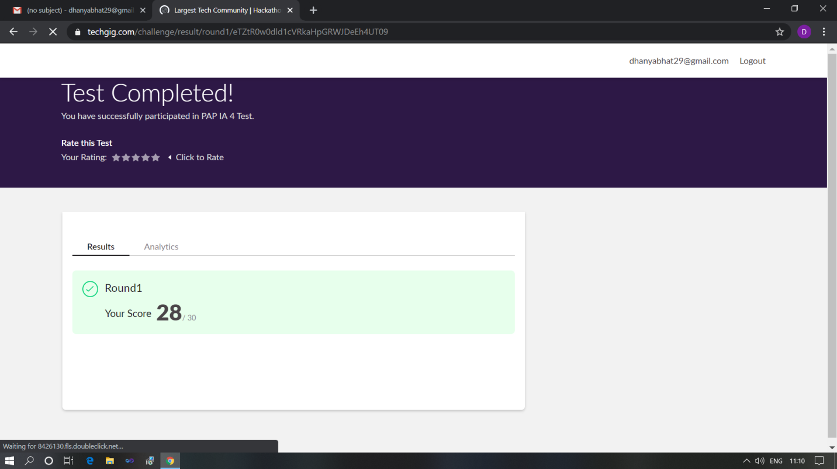

Scored 29 out of 30 in PAP test

Certification Course Details: (Attach the snapshot and briefly write the report for the same)

Coding Challenges Details: (Attach the snapshot and briefly write the report for the same)

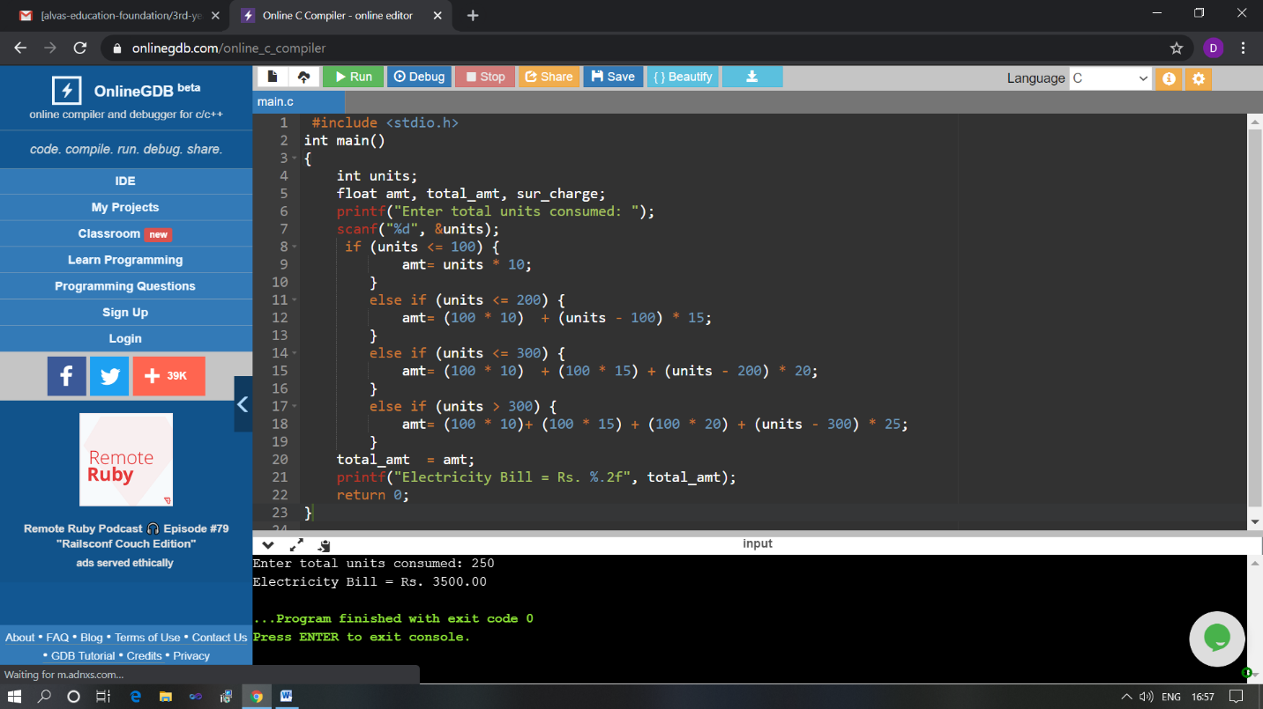

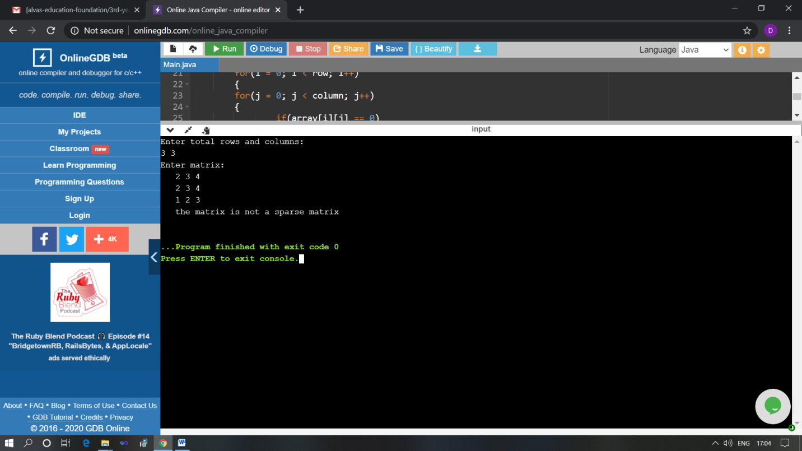

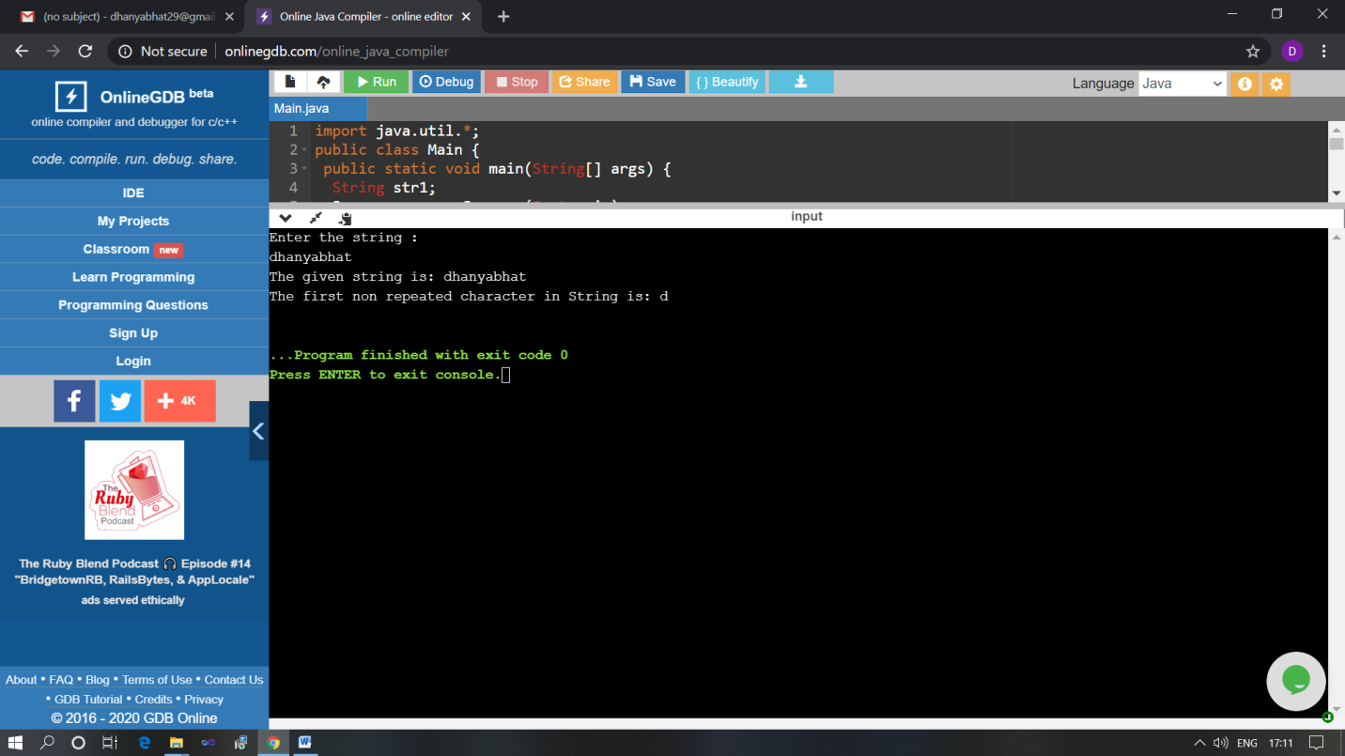

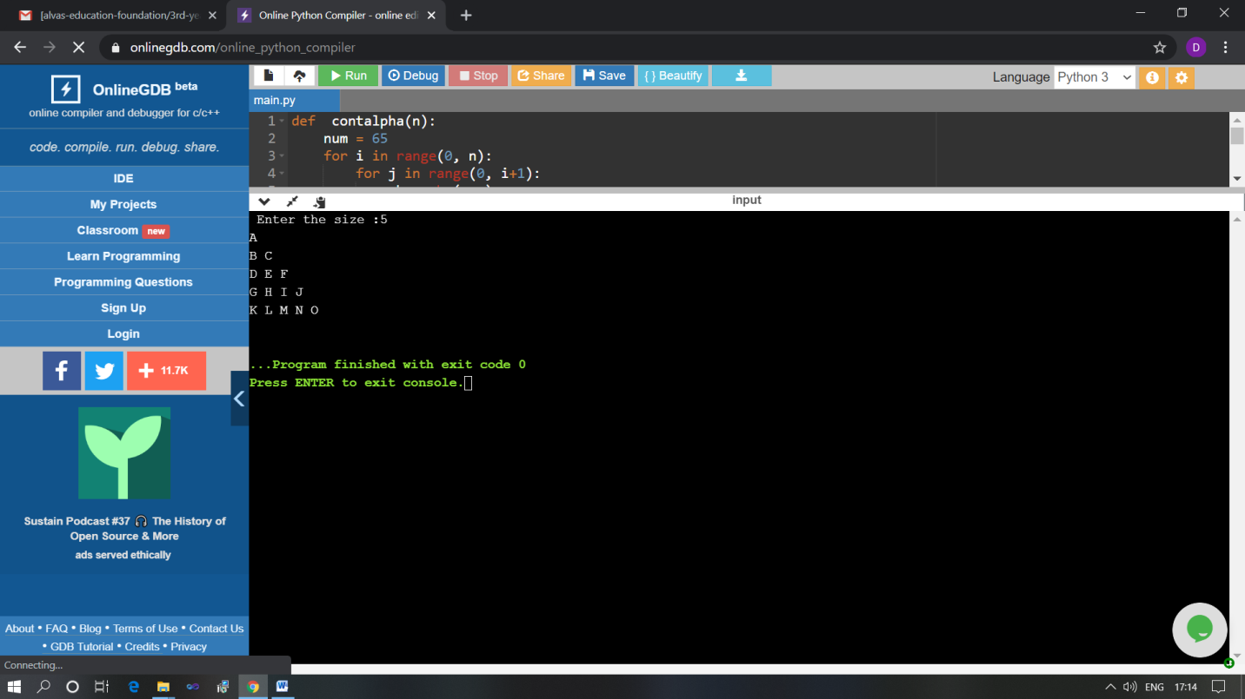

The above Programs were written and executed and the output of the same is displayed above. The code for those 4 programs have been uploaded to the github repository and the link to the same is provided on the form.